Verification Document

Please read the README.MD file that can be found after unzipping member-stats-sync-lambda.zip in order to understand how to configure the lambda and deploy it.

1. Configure DynamoDB Stream for Lambda Trigger

- Go to the table in DynamoDB

- Click on Manage Stream

- Choose View type “New and old images”

Below screen shot is for reference, your table name maybe different.

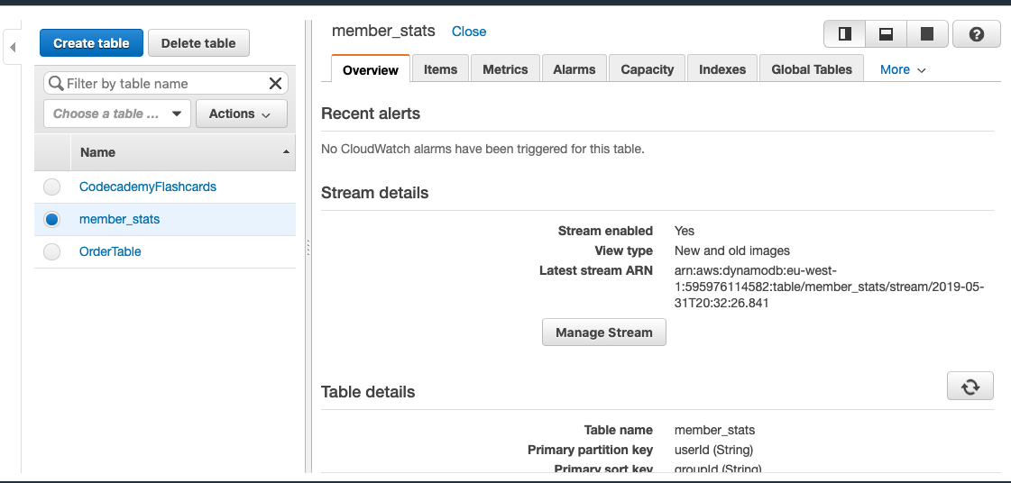

2. Unit Test Result

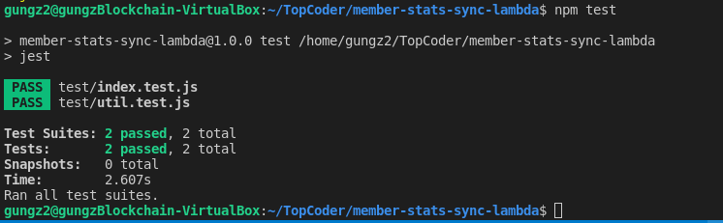

3. Deployment Result (running serverless deploy)

1. Command Line

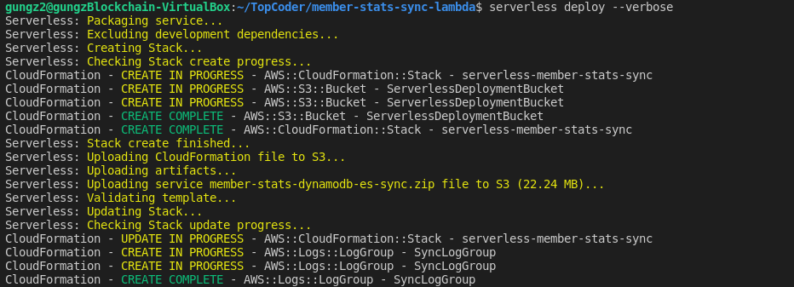

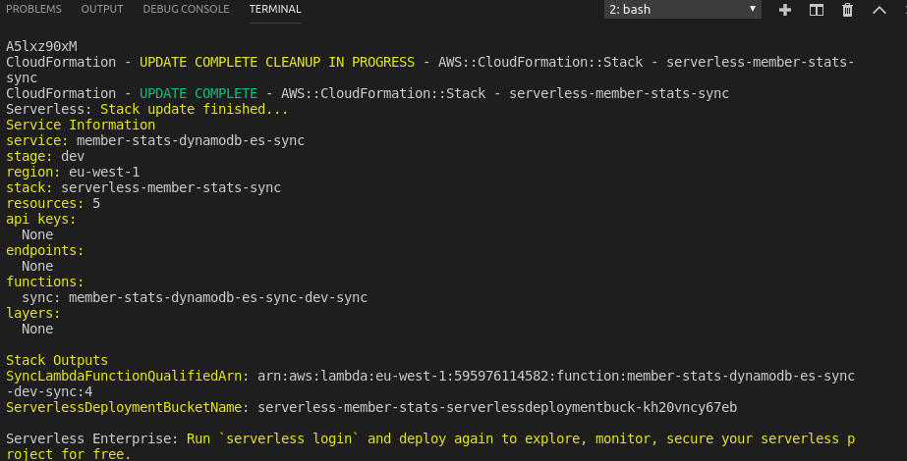

1. AWS Console Evidence (Cloud Formation and Lambda)

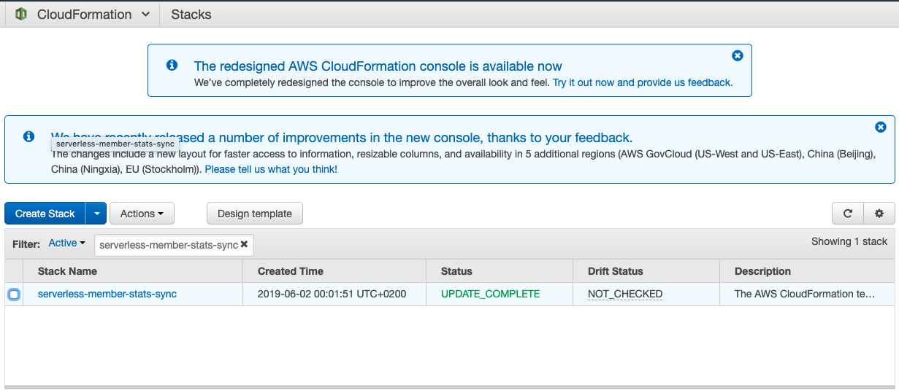

Cloud Formation Stack is created by serverless

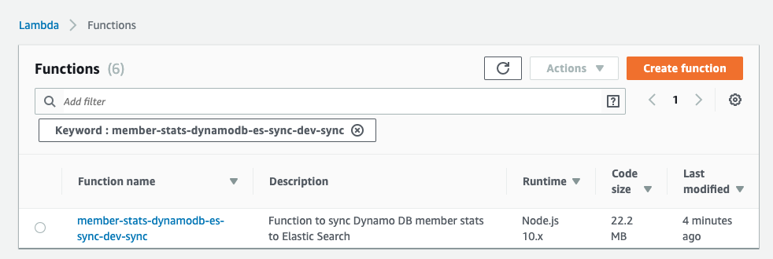

Lambda is deployed by CloudFormation

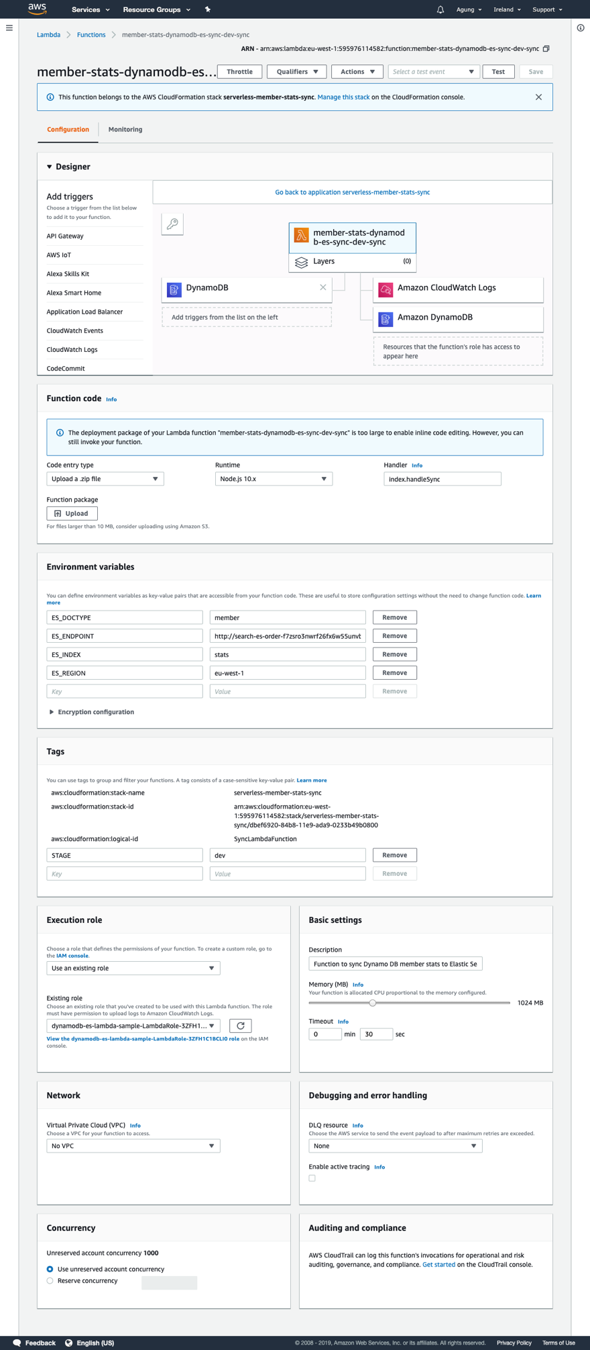

The Detail of Lambda deployed by CloudFormation (Environment variables and Exection role are populated by CloudFormation from serverless.yml)

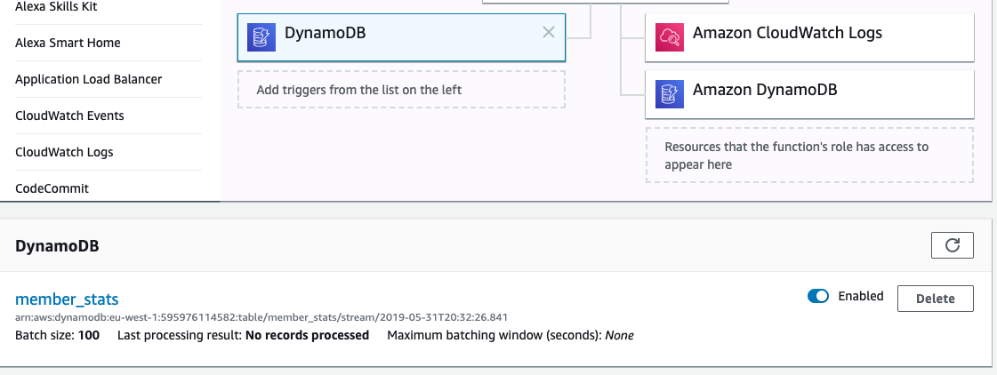

The Detail of Lambda Trigger deployed by CloudFormation (DynamoDB stream is populated by CloudFormation from serverless.yml)

4. Manual Testing of Lambda

a. Insert Record to DynamoDB Table

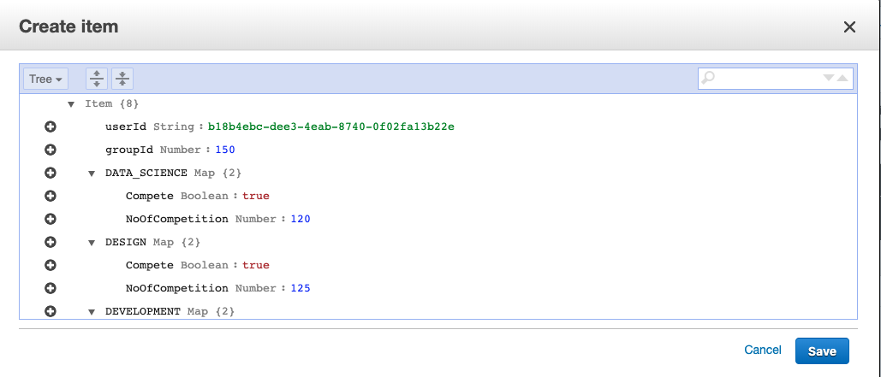

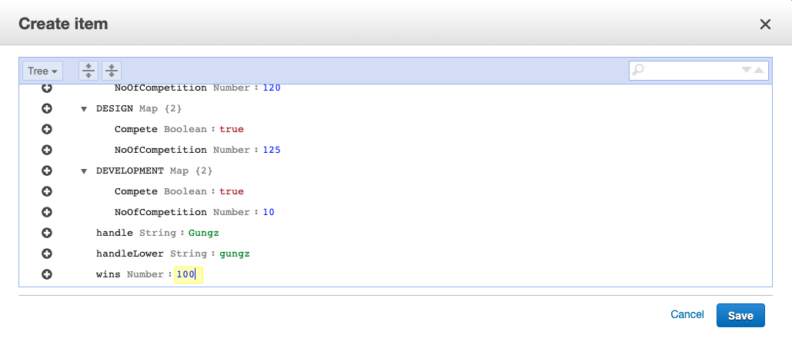

DynamoDB

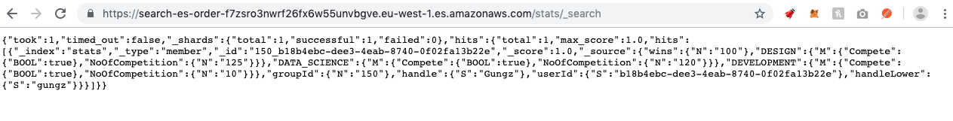

ElasticSearch

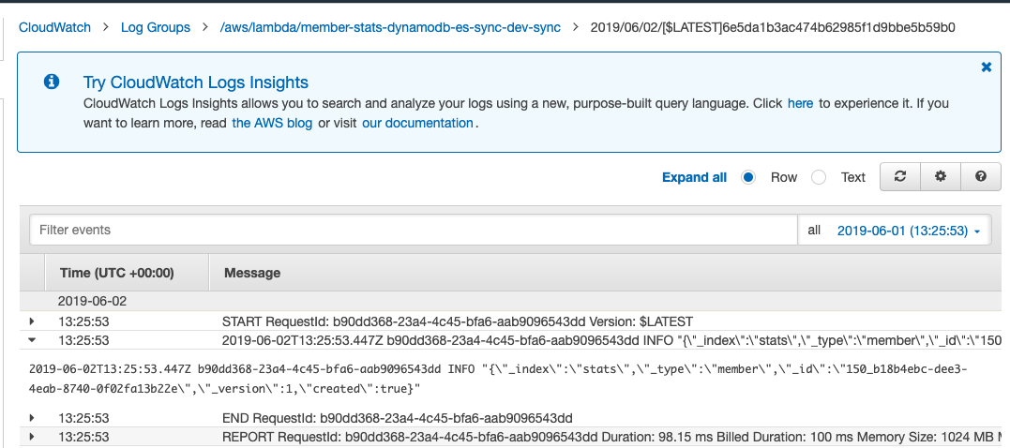

CloudWatch Log

1. Update Record in DynamoDB Table

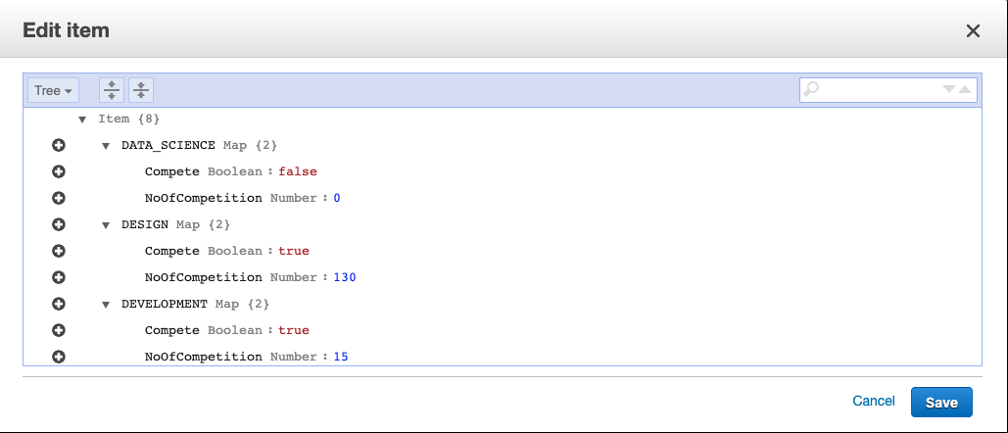

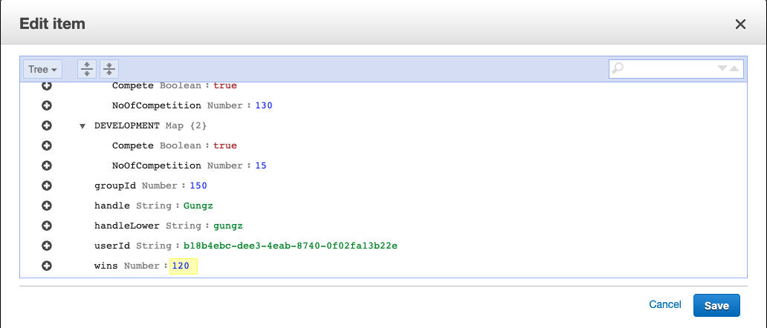

DynamoDB

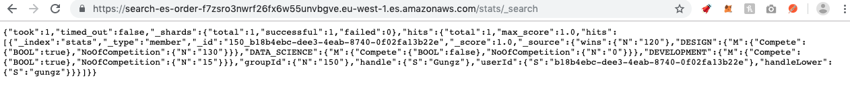

ElasticSearch

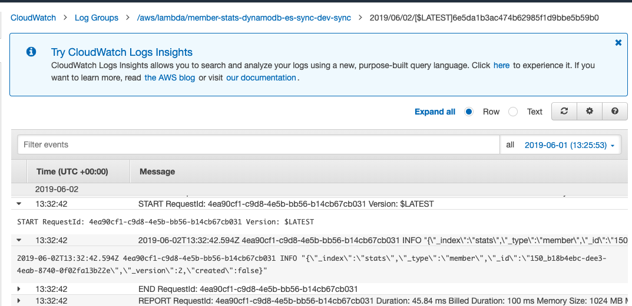

CloudWatch Log

1. Delete Record in DynamoDB Table

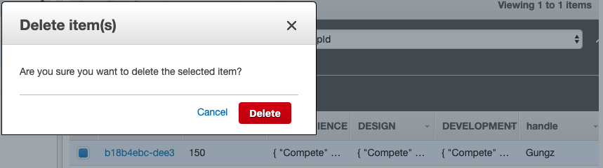

DynamoDB

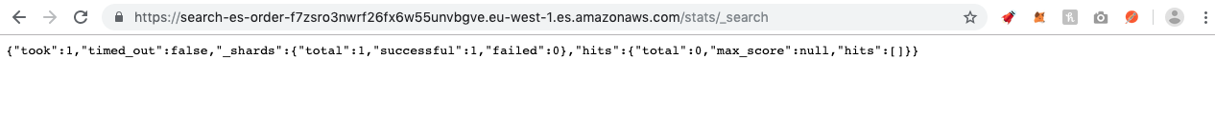

ElasticSearch

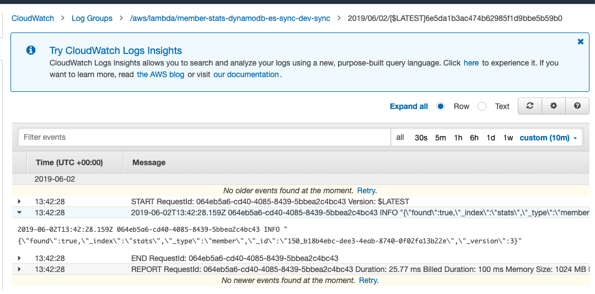

CloudWatch Log